

Javascript Assignement 4

FSE Javascript Assignment



November 13, 2018

Cognizant

Kolkata

Contents

**PROJECTS:** 4

**EXPERIENCE:** 5

**PERSONAL BIOGRAPHY:** 6

# **PROJECTS:**

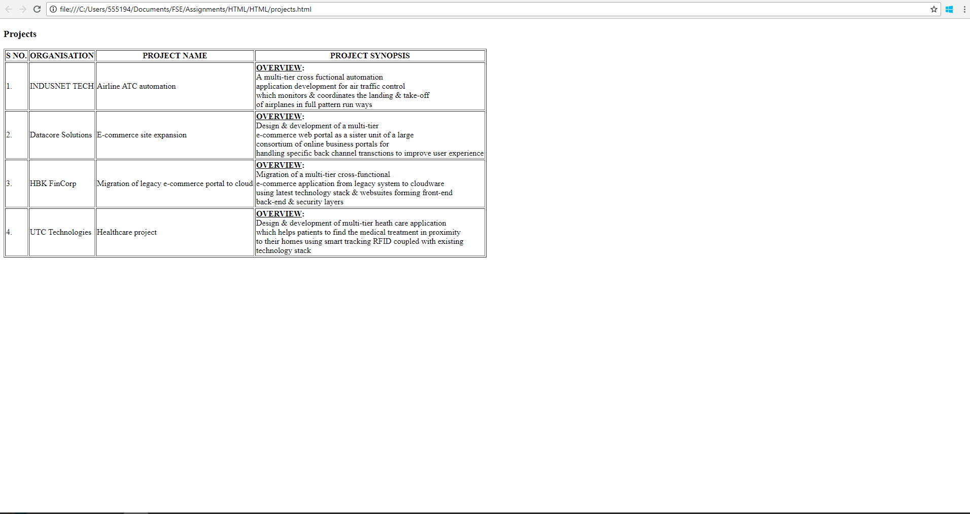



# **EXPERIENCE:**

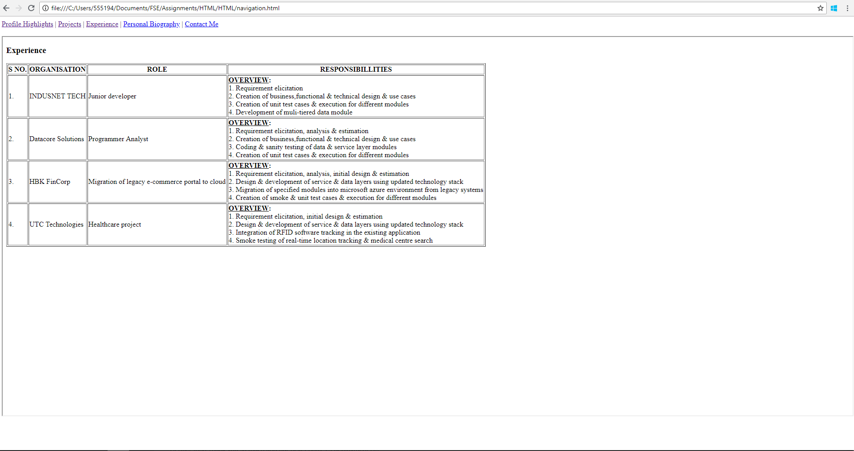

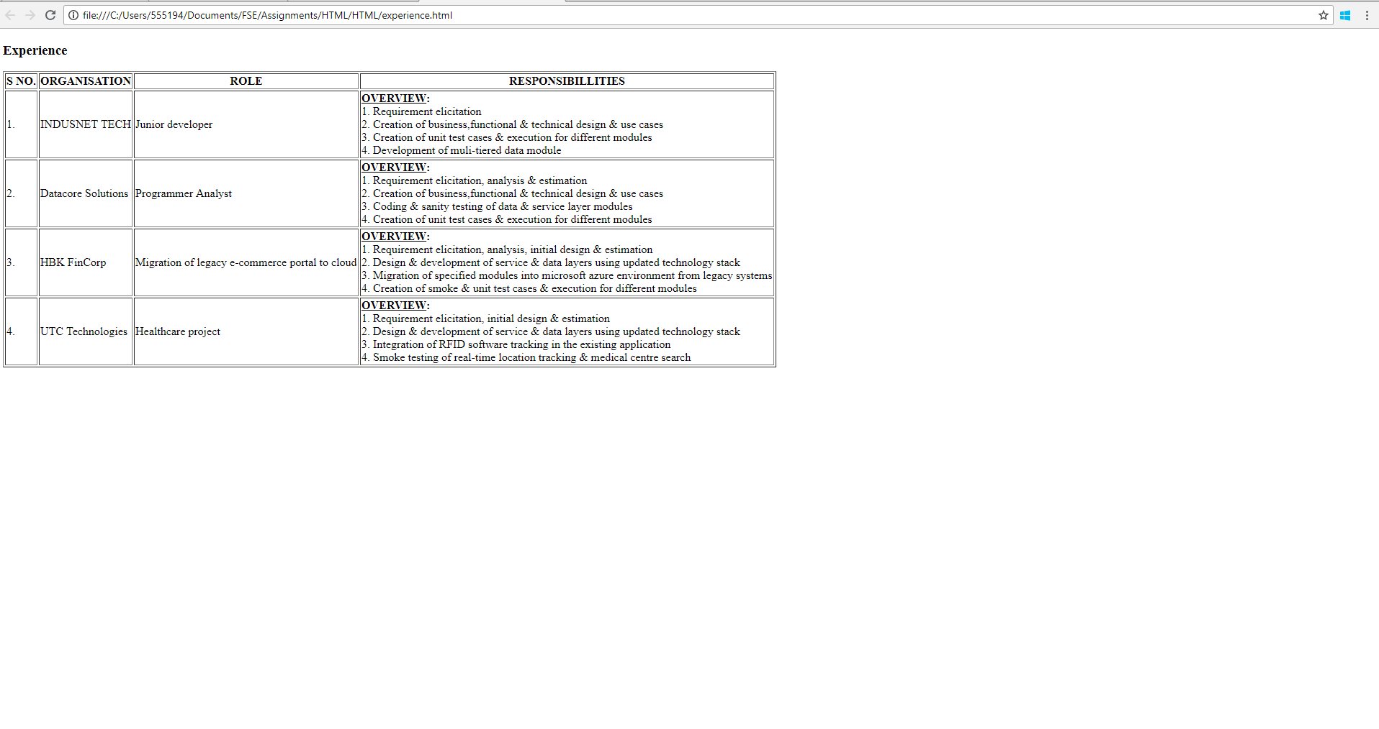



# **PERSONAL BIOGRAPHY:**

